Maths

Following the White Rose Maths scheme, the children will be focussing on the following concepts:

Subtraction

Multiplication and Division

(by 2, 3, 4, 5, 8 and 10)

*Times tables and Fluency Facts will continue to be focuses for learning at home alongside the weekly homework.*

**Year 3** **Curriculum Overview**

**Autumn Term 2 2024**

Guided Reading

This half term, we will read ‘The Iron Man’ by Ted Hughes. The children will read this high-quality text and complete a range of activities (linked to the Reading Dogs) to develop their comprehension skills.

Art

In Art, children will be focussing on drawing in our unit ‘Growing Artists’. They will be creating tone by shading, adding texture to drawing, using observational skills to create detailed studies of plants, before finally creating an abstract composition.

Science

This half term, we will continue to learn about ‘nutrition and diet’ by comparing diets of humans and animals. We will then explore sustainability by focusing on ‘food waste’. We will consider what food waste is and how we can reduce it. Finally, we link our History topic to our Science to explore ‘Rocks’. During this unit, we will identify rocks, group them in a variety of ways, test different rocks and explore our local area, conducting a rock survey,

Music

In Music, we will make links to our Geography unit about volcanoes. We will explore how changes in tempo, dynamics and texture create effects in music. We will try to read, record and perform ideas before creating a piece of music as a group and performing it.

Geography

Our project this half term focusses on Volcanoes and finding out why people might live near them.

During the unit, the children will learn about the layers of the Earth, how and where mountains are formed, why volcanoes happen and where they occur, the effects of a volcanic eruption, and finally, what earthquakes are and where they occur.

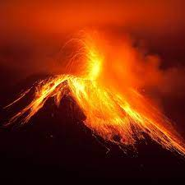

PE

Games will take place on a Wednesday. PE will take place on a Thursday.

This half term, our PE focus is Gymnastics.

Our Games focus will be Football.

Religious Education

Our focus this half term is ‘What is the Trinity?’ During this unit, the children will be using the Theology ‘lens’ and thinking through believing,

Computing

This half term we will gain the skills needed to code a simple animation in Scratch. Children will learn that inputting commands will cause the sprite to respond in a desired way. They will add sounds and backgrounds to create their planned effect.

PSHE

This half term we will focussing on the ‘Health and well-being’. We will learn ways to keep our body healthy including eating a balanced diet and understanding why we make certain choices (links to the media etc). We will also learn some basic first aid.

French

This half term, children will focus on remembering and recalling, from memory, 10 common animals in French with the correct article/determiner. They will revisit their phonics from last half term focussing on: CH OU ON OI

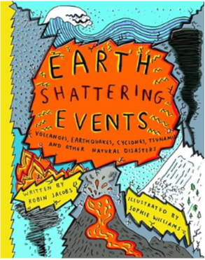 English 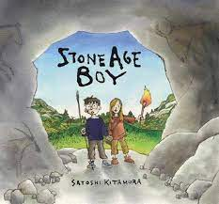

This half term we will complete our writing about the text ‘Stone Age Boy’. We will then create non-chronological reports, using the text ‘Earth shattering events - Earthquakes’ as inspiration. We will use a small-step approach to help us follow an appropriate structure, and choose the best vocabulary. when writing our own report at the end of the unit.